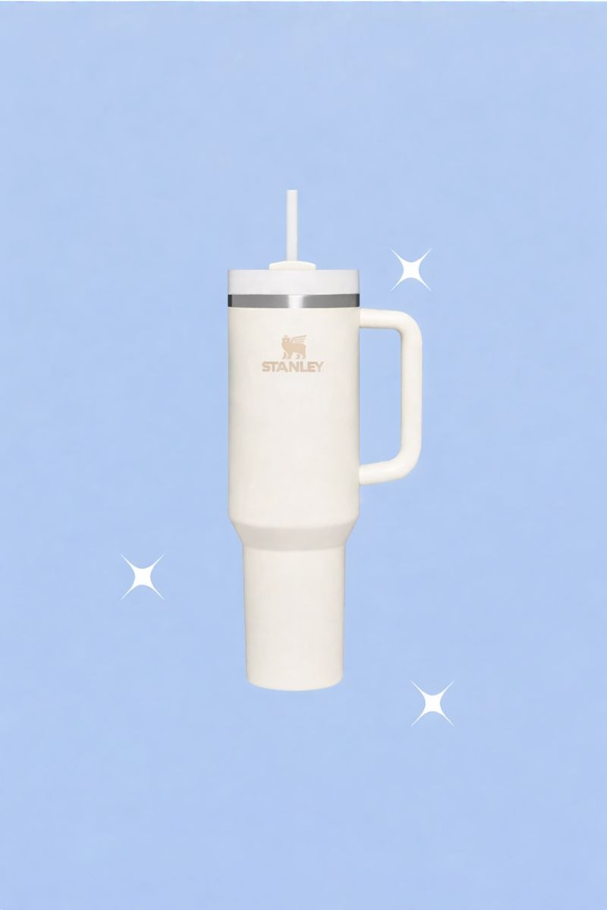
Table of Content
Introduction – Executive Summary…………………page 1
A. Brief History, Target Market, Main Products, and Competitors …………………………page1
Who is Stanley? What is their history? …………………………page1
Products Sold …………………………page2
Target Market…………………………page2
B. Overview of Advertising Plan…………………………page3
Situation Analysis…………………………page3
Internal Factors…………………………page4
Industry Analysis …………………………page4
Competitor Analysis…………………………page4
PESTEL Analysis…………………………page4
A. SWOT Analysis …………………………page5
Strengths …………………………page5
Weaknesses …………………………page5
Opportunities …………………………page5
Threats…………………………page5
B. Key Communication Problems and Solutions…………………………page6
Key Planning Decisions…………………………page6
A. Objectives…………………………page6
B. Target Audience …………………………page7
Demographic …………………………page7
Life Stage …………………………page7
Geographic …………………………page8
Psychographic …………………………page8
Behavioral…………………………page8
C. Competitive Advantage …………………………page9
Featured Benefit …………………………page9
Secondary Benefit …………………………page10
High vs. Low Involvement Product …………………………page10
Consequences for Strategy…………………………page11
D. Product Image, Position, and Personality …………………………page11
Product Image …………………………page12
Product Position …………………………page12
Product Personality…………………………page13
E. Suggestions for Improving Product/Offering …………………………page14
Design Improvements …………………………page14
Pricing Strategy …………………………page14
Packaging Improvements …………………………page15
Distribution Improvements …………………………page15
Policy Improvements …………………………page15
Additional Promotional Strategies…………………………page16
Advertising Creative Strategy…………………………page16
A. Communication Strategy …………………………page16
Directness of Message …………………………page17
Appeal …………………………page17
Storytelling Approach…………………………page17
B. Copy Elements …………………………page18
Slogans and Taglines …………………………page18
Long vs. Short Copy Length …………………………page18
Direct Response Devices…………………………page18
C. Visual Elements …………………………page19
Logo …………………………page19
Visual Appeal…………………………page19
D. Audio Elements…………………………page20
Advertising Media Strategy…………………………page20
A. Media to Be Used …………………………page20
Traditional Media …………………………page20
Online Media …………………………page21
Specialized Non-Traditional Media…………………………page21
B. Media Objectives: Reach and Frequency …………………………page22
Reach …………………………page22
Frequency…………………………page22
Campaign Execution & Management…………………………page22
Campaign Timeline…………………………page23
Budgeting Method and Allocation …………………………page24
Performance Metrics & Impact Analysis……………………. page 24
Measurement Tools and Analytics……………………. page 25
campaign evaluation ……………………. page 25
Recommendations & Future Improvements……………………. page 25
Campaign Strengths and Weakness……………………. page 26
Future Advertising Strategies……………………. page 26
Technological and Artificial Intelligence Innovations……………………. page 26
Commercials…………………………page26
References…………………………page27

Introduction – Executive Summary
- Brief History, Target Market, Main Products, and Competitors
Who is Stanly? what their history
Stanley has a long history, but lately, it’s their famous tumbler that’s been turning heads, especially in Jordan. This campaign highlights the Stanley Tumbler, using smart marketing tactics to connect with young Jordanians—mainly active women. The goal? Get people talking about the brand, make them want to buy, and keep them coming back for more. The team relies on predictive analytics to figure out what clicks with the audience.

So, who’s the focus? Mostly young folks living in big cities like Amman, Irbid, and Zarqa. These are people glued to social media, who care about sustainability, style, and products that last. Stanley’s marketing puts the spotlight on how tough and reliable their tumblers are—not just in looks, but in performance—and the fact that they’re eco-friendly doesn’t hurt.

To reach these city dwellers, the campaign uses platforms that matter in Jordan: Instagram, TikTok, influencer partnerships, and eye-catching billboards. The plan is to boost brand recognition, spark more interaction, and drive up sales. On top of that, chatbots will help make customer interactions easier and more personal. Demopoulos, A. (2024)

Product sold
Stanley made its name with the iconic bottle, but their lineup goes way beyond that. They produce all sorts of durable, high-quality gear. Sure, outdoor enthusiasts love their stuff, but Stanley also wins over craftsmen, homeowners, and anyone who likes a good DIY project.

They’ve got hand tools—think hammers, screwdrivers, pliers—and a solid range of power tools like drills and saws. Need somewhere to stash your gear? They offer toolboxes and backpacks for storage. Plus, there’s outdoor equipment: coolers, camping cookware, and of course, those famous insulated bottles. DIY (do-it-yourself)

Target market
At its core, Stanley speaks to professionals—craftsmen, construction workers, serious DIYers, and outdoor adventurers. The Stanley Quencher, for example, started out as a rugged tool for tradespeople, but with a few tweaks—like a straw, a handle, and more eco-friendly materials—it now appeals to hikers and anyone who loves the outdoors.

A big part of Stanley’s recent success comes from sharp social media campaigns and influencer collaborations. They’ve managed to reach not just their original audience but also women between 35 and 44 and other new market segments. (Soar with Us, 2024)

Overview of Advertising Plan
In Jordan, Stanley’s strategy zeroes in on young, energetic women in the medium to upper-middle class. The focus: eco-friendly design and that stylish, adventurous vibe. The ads are designed to grab attention and strike an emotional chord, showing off the tumbler’s non-toxic materials and modern look.

The marketing plan covers three main areas: making ergonomic design upgrades, offering both premium and budget options, and rolling out new packaging and distribution methods to keep customers happy and loyal. The campaign leans on emotional storytelling, product reviews, simple visuals, and upbeat audio. You’ll see Stanley across traditional media—like TV and magazines—and all over social platforms: Facebook, Instagram, TikTok. They’re also teaming up with influencers and sponsoring events to build buzz.

The goal is clear—reach 80% of the target crowd in the next six months. By doing this, Stanley expects to deepen relationships, boost sales, and build real loyalty.

Situation analysis

Internal factors
Stanley’s got a strong, creative marketing team that knows how to craft campaigns people actually pay attention to. They use data to guide their ad spending and pick the right topics to connect with customers. People respond well to Stanley’s ads because they speak to what matters to them. The company’s work with influencers helps them reach even more people. At the heart of Stanley’s brand is a reputation for sustainability, reliability, and a sense of tradition—and that keeps customers coming back.
Industry analysis
Stanley Water Cup is a U.S.-based brand established in 1913 by William Stanley, known for its all-stainless-steel vacuum-insulated cups. Initially labeled as a failed product due to low sales, the brand underwent a significant transformation by shifting its focus from male outdoor enthusiasts to women, while highlighting emotional connections and brand storytelling. This strategy began to show success when reality TV star Emily Maynard showcased the cup on Instagram, leading to rapid sales increases. Under the leadership of former Crocs CMO Terence Reilly, Stanley embraced a broadened marketing approach, appealing to a female demographic and launching new color variations in their Quencher line. Noteworthy incidents, like a viral video of a Stanley cup surviving a car fire, further boosted the brand’s reputation. As a result of these strategies, Stanley’s revenue soared from $94 million in 2020 to $750 million in 2023, with the Quencher becoming particularly popular across diverse consumer segments. Stanley's marketing prowess has capitalized on new media channels, integrating efforts across various platforms to maximize outreach and engagement.

1. Market Growth and Size
Stanley Water Cup, Jordan Amman -based brand, established by William Stanley in 1913, has experienced significant expansion as a result of a market positioning shift from catering to outdoor men to appealing to women consumers. The company posted significant growth in revenues by implementing a number of market-targeted programs, such as the launch of their Quencher series, and now records significant financial performance, standing at $750 million as of 2023, compared to $94 million in 2020.
2. Technological innovation
Stanley has created vacuum-insulated drinkware made from stainless steel to retain the initial temperatures of drinks in the product for a significantly extended period. The organization demonstrates innovation by continuously improving their product lines, such as the Quencher series of drinkware, to meet consumer preference by offering a variety of colors and improvements in product designs.
3. Health & Wellness
The brand focuses on product safety and excellence with non-toxic and long-lasting cups perfect for active people. The brand caters to women looking for functional yet fashionable drink ware, which targets the well-being trends in the market today.
4. Growth in E-commerce
Stanley utilized digital marketing techniques as well as the emergence of various media platforms in order to increase visibility. The Stanley Cup gained popularity as a result of media coverage on Instagram postings of Emily Maynard, as well as a viral video showcasing it as it survived a car fire. This resulted in the amplification of e-commerce growth through engaging various digital platforms.

Analysis of competitors

In the drinkware sector, Stanley faces numerous competitors. These rivals account for a sizable portion of the market share and are also well-established businesses. They are well-known for their reusable insulated water bottles in a variety of sizes and designs, and they provide very similar products to Stanley.
The YETI mugs are the first rival. They are renowned for their superior quality, longevity, and sophisticated insulation. However, they target the upper classes, which restricts their reach, because potential buyers may see their high costs as a disadvantage. However, this gives them the chance to expand their product line and develop a more reasonably priced one.
The second rival is Hydro Flask, whose designs, vivid color choices, and water bottle insulation make them more appealing to younger consumers. Their distinctive selling proposition is their aesthetic, which draws customers in with its vivid hues and patterns. When compared to other companies, its pricing strategy is seen as being in the higher-end ranges. However, because so many new companies are selling comparable goods, they are vulnerable to both market saturation and counterfeit goods.
Contigo is the third rival; their water bottles emphasize usability and price. They use auto-seal technology, which is practical and marketable to both professionals and families. They are also easily accessible in every store, however because of their low price, they are not seen as a premium brand in comparison to other brands of water bottles. Additionally, because they are competing with both premium and non-premium brands in the market, their rivals are operating on a larger scale (Augustin, n.d.).

PESTEL Evaluation

1. Political aspects

The problem is that certain nations would rather promote domestic goods, which could have an impact on Jordan Stanley’s operations and lower sales.
-Tariffs and trade regulations in Jordan can affect prices and supply chains. Sanctions on raw resources, particularly across big markets, are the cause of these swings.
2. Economic aspects

In terms of supply and demand, market conditions can have a significant impact on businesses.

The company is impacted by raw material prices because of changes in the cost of steel and aluminum, which are components of the goods.

3. Social factors:
Since Jordan consumers are growing more conscious of the environment, environmental awareness is one of the elements that helps the business.
The market for Stanley's products is rising due to the healthy lifestyle trend, which encourages individuals to be more active and engage in outdoor activities.
4. Technological factors:
Because Stanley uses cutting-edge technologies in their goods, such as insulation, durability, and light weight, they are at the top of their field.
-Having a strong online presence, such as an online store, enables the business to reach a larger audience, expanding its sales and global reach.

5. Environmental aspects

Customers demand and expect Stanley's goods to have a minimal environmental impact because they may be reused. Stanley is under pressure to make its production methods more ecologically friendly due to the current trend of promoting sustainable environmental practices.
6. Legal considerations:
In order to guarantee customer satisfaction, Stanley complies with consumer protection regulations by providing warranties, product returns, and refunds. The property must be patented in order to prevent lawsuits brought about by fake goods.
Swot analysis
Strengths
- There is a strong brand heritage in the case of Stanley as a known and respected brand for drinkware since 1913.
- The items come with double-wall vacuum insulation to provide optimal temperature retention for both hot and cold drinks.
- The use of sturdy materials in making Stanley bottles makes them durable enough to be used outdoors as well as in day-to-day activities.
- The leak-proof nature of the products sold by Stanley adds to the advantage of convenience for those who need to carry the products along.
- The brand provides an assorted range of different styles and colors to cater to different consumer preferences and to supplement market appeal.
- The company promotes sustainability as a feature of its products, targeting consumers who value the environment.
- Stanley has an established distribution network, thereby making their products available in various retail outlets.

Weakness
- The premium pricing model could act as an entry barrier to cost-sensitive consumers.
- Stanley's appeal to outdoor enthusiasts by Stanley may disregard other possible consumers who require beverage containers for other purposes.
- The brand may confuse consumers and make it difficult for them to choose among the numerous offerings.
- The lack of extensive marketing could hamper growth considerations for regions with increasing trends towards outdoor activities.
- Consumers might consider Stanley products too bulky, possibly acting as a barrier for potential customers.
- The traditional retail outlets may limit the online sales in relation to the rapid growth of e-commerce.
- The brand may have difficulty in keeping up with rapidly shifting consumer preferences and trends in the drinkware industry.
- The potential risks to the supply chain could impact production, particularly around peak periods.

Opportunities
- The rise in the demand for outdoor pursuits and adventure tourism could enable the company to diversify its product lines to cater to such customers.
- The growing interest in sustainable goods can also be harnessed by promoting the sustainable efforts of Stanley.
- The growth of e-commerce offers a chance to improve the website and direct-to-consumer sales approach for Stanley.
- Influencer partnerships and brands with connections to the outdoors can help to provide exposure to new markets.
- Going international, especially in regions where there is an emergent outdoor culture, can fuel sales.
- The creation of limited-edition, seasonal products can build buzz around them, which helps in increased sales.
- Investment in innovative product attributes such as smart technology can appeal to tech-savvy customers.
- A program of customer loyalty can increase customer retention and boost repeat business.

Threats
- The competition from existing brands of drinkware, like Hydro Flask and YETI, is very intense.
- Emerging brands competing with price-effective alternatives can draw price-conscious consumers, affecting the market share of Stanley.
- Consumer preference shifts towards minimal or lighter-weight lines may negatively impact Stanley’s heavier product lines.
- Economies may go through recessions that dampen discretionary expenditure, impacting high-end drinkware sales.
- Changes associated with the regulation of materials that go into the production of drinkware may increase production costs. 6) Adverse consumer reviews or product recalls may negatively impact the brand's reputation and consumer confidence. 7) Global occurrences like pandemics or geopolitical tensions may disrupt product supply chains. 8) The rise in interest in consumer products related to ‘health’ and ‘wellness’ could shift consumer attention towards hydration products, which do not align well with the current brand portfolio of Stanley.

B. Important Communication Issues and Their Solutions

When making an advertisement for Stanley 1913, it is crucial to make sure that the communication messages are clear, precise, and cannot be misinterpreted. This is because any misconduct during the advertising process can damage the company's reputation to the point where it may be difficult to repair.
Many things can go wrong when it comes to Stanley, and specifically with their marketing or promotion of the Stanley Cup, a lot of things need to be taken into account when running the advertising campaigns. First, the phrase "Stanley Cup," which is Stanley's most well-known

A significant investment in differentiating the Stanley Cup for beverages from the Stanley Cup for hockey is part of the suggested strategy to improve Stanley's branding. Using distinctive logos, thorough product descriptions, and pertinent taglines are important tactics. Additionally, as Stanley offers a variety of products that cater to different client categories, which can confuse advertising efforts, marketing messaging must be in line with the intended audience. To effectively adapt messaging and comprehend customer wants, comprehensive market research is necessary. Maintaining consistency in messaging across all platforms is essential; inconsistent advertisements on social media, websites, billboards, television, or print can mislead consumers and damage a company's reputation. A cohesive advertising campaign that is consistent in terms of information, themes, colors, and images will help to establish a strong brand identity in the minds of customers. (EP74 | The problem with online communication - with Davina Stanley, n.d.).

Key Planning Decision
- Objectives
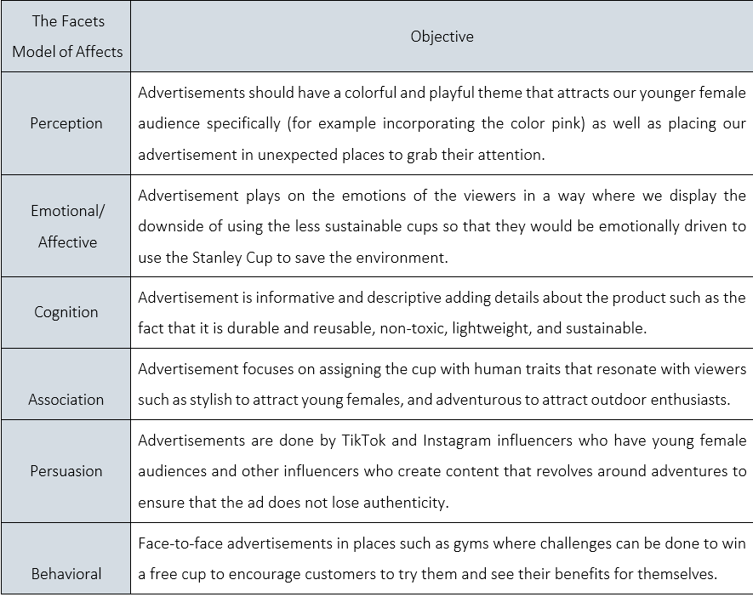

B. The intended audience

The demographic
The Stanley tumbler, the product we selected, predominantly targets women because of its shape and appearance, vivid colors, and straw usage. Although Caucasians make up the majority of the population, their base is growing to include other ethnic groups. The middle-class to upper-middle-class consumers who buy these goods are often well-educated and pay premium pricing from Stanley.

stage of life
The product we selected primarily appeals to those between the ages of 16 and 25, but it also appeals to people beyond the age of 55. These individuals may be family-oriented or even those who lead busy, outdoor lifestyles.

Geographical
Since the tumblers are an American brand, the US is their primary target market, they have been expanding to other areas as well. Because of its excellent insulation and ability to hold both hot and cold beverages, the cup is perfect for any temperature.
Psychographic
The product is aimed at middle-class to upper-class consumers who appreciate high-end goods. Due to the product's durability and ability to sustain busy lives, they lead an active lifestyle and pursue outdoor hobbies. People who are concerned about ecology and sustainability will also find it appealing. The product's simplicity and sole hydrating purpose make it somewhat appealing to those who prefer a basic look.

Behavioral
Stanley tumblers are useful for a variety of tasks, such as daily routines, travel, work, and outdoor activities. They are seen as indispensable by their users, demonstrating the high level of brand loyalty among their clients who cherish this brand, leading to their becoming brand ambassadors and positive word-of-mouth. (Brand Focus: Are you a Stanley stan, n.d.).
c. competitive advantage
Highlighted Advantage

The Stanley 1913 cup has a classic, fashionable appearance and is an eco-friendly product. It makes a fashion statement and is dependable for usage in any weather. It has an attractive look and maintains beverage temperature thanks to its appropriate stainless-steel construction.

Secondary advantage

Because of its many ancillary features, the Stanley Cup draws a wide range of consumers, especially those who value customization in terms of color and style and are fashion-conscious. Its lightweight and ergonomic shape, which fits neatly in car cup holders, makes it easy to handle. These attributes also improve its visual appeal. Additionally, the Stanley Cup is categorized as a high-involvement product due to its longevity and high-quality construction, which sustain beverage temperature in a variety of weather conditions. Customers are prompted to do extensive study before making a purchase by its premium pricing. Regardless of price, outdoor enthusiasts and fashion-conscious consumers find the Stanley Cup to be worth the expenditure due to its perceived value and compatibility with their lifestyles.

Implications for strategy

The following should be taken into account by the business when creating its advertising plans because the Stanley Cup is regarded as a high-involvement product:
The dissemination of comprehensive details about the Stanley Cup's functions, advantages, characteristics, and costs. Videos and images that show how to use the product correctly can be used to do this.
By ensuring outstanding quality and performance through client testimonies, a brand can improve its reputation.
Delivering exceptional customer service by providing post-purchase assistance to address any questions, grievances, or comments; increasing loyalty.
By emphasizing the exceptional qualities of the product, such as durability, functionality, and flexibility, captivating storytelling tactics are used to alter the brand's image and identity in the minds of consumers in a way that represents its value.

D. Product Image, Position, and Personality
The Stanley Cup is a dependable, long-lasting, and performance-focused product that is perfect for active lifestyles, according to Product Image, Position, and Personality. The tumblers are positioned as both elegant and resilient, representing confidence and adventure. Their distinct identity, which sets them apart from rivals and highlights their insulation and toughness, is derived from their legacy and craftsmanship. In the end, Stanley is intended to be a reliable exploration and resiliency partner.

E. Ideas for Enhancing the Product/Offering
Enhancement of design
By enhancing tumbler design for improved comfort and grip, adding customization choices like engraving and different colors, and launching a new line with infuser sections, Stanley may improve its product offers. Increasing the variety of tumbler sizes will also serve a larger market, boosting consumer satisfaction and giving businesses a competitive edge.

Strategy for pricing

Enhancing Stanley Tumblers' pricing approach could aid in the company's market segment expansion. For instance, launching a line of affordable tumblers with all the necessary characteristics and a premium line for those who wish to utilize all the extra performance aspects

to better serve a variety of clients. Offering seasonal, holiday, Black Friday, back-to-school, and university-related discounts may further boost sales.
Finally, providing bundles that include a tumbler and its accessories, like as cleaning brushes and various straws, can add value and encourage more consumption.

Enhancements to packaging

Improving packaging to make it more recyclable and environmentally friendly will be a wonderful fit with Stanley's sustainable and plastic-free image. By emphasizing the value of being environmentally friendly, even in the packaging, their marketing campaigns will improve their standing with consumers.
Stanley will be more enticing to use on gift-giving occasions if new packaging designed specifically for gifts is created. Customers' experience with Tumblers will also be enhanced by include care instructions on the packaging and a QR code that leads straight to a video with these instructions.

Improvements in distribution

For its Tumbler line, Stanley might employ a variety of distribution strategies to increase its reach through various channels. Optimizing the company's website and the most well-known and popular e-commerce sites, such as Amazon and eBay, can boost online sales. This can be achieved by making the website easy to use and user-friendly, offering a seamless experience that will speed up and simplify the shopping process Stanley Tumblers' distribution can be further expanded by establishing connections with physical and online retailers, which will aid in boosting availability across various areas. Stanley will be able to advertise their Tumbler at numerous points of sale by working with well-known retail establishments, pop-up stores, and booths in large malls. Additionally, strategically putting the Tumbler will draw Stanley's clients, thus boosting sales. These locations contain areas dedicated to outdoor gear, fitness centers, and cooking equipment. Stanley will be able to present new consumer categories for Tumbler users and increase sales by increasing distribution.

Enhancements to policy

Enhancing Stanley Tumblers usage guidelines can enhance customer satisfaction and experience. This can be achieved by offering loyalty programs and points to loyal consumers, which will increase brand trust and loyalty. Customers will feel more comfortable doing business with the company in the long run if it has a guarantee policy that allows them to return and exchange items if necessary, along with an extended warranty duration.
Other marketing techniques might consist of:

Working together with outdoor enthusiasts and influencers to market the product and showcase it in natural environments.
-Customers should share their Stanley Tumbler experiences on various media, and advertising campaigns should utilize these posts.

Advertising Creative Strategy

- Communication Strategy
The marketing strategy known as "soft sell" places a strong emphasis on nuanced strategies that sway consumers by appealing to their emotions and projecting a positive company image. It emphasizes a product's emotional appeal rather than only its physical attributes. For instance, using a soft sell approach to promote Stanley Tumblers is appropriate since it highlights the Tumbler's qualities, like its style and adaptability for outdoor activities. Commercials might show consumers interacting with the Tumbler in several settings, such as at home or on hikes, demonstrating its capacity to sustain the ideal temperature for prolonged periods of time. In addition to highlighting the Tumbler's features, the main message would also highlight the improved Stanley user experience.

Dramatic

By employing drama, marketers craft a narrative in which characters engage with one another, allowing consumers to form opinions about the product based on what they see. Stanley is able to depict various situations in which individuals are utilizing their tumblers. For instance, a worker sipping coffee in the morning or a hiker sipping cool water. In order to allow viewers to observe how the tumbler is integrated through various situations, characters will respond organically rather than speaking to them directly.

Rational Appeal
Stanley's commercials emphasize the practical advantages of their tumblers in an effort to help consumers make decisions. They stand out for features like double insulation, which keeps drinks hot for 12 hours and chilled for 16. Durability is guaranteed by the use of premium stainless steel, and a dedication to safety is demonstrated by the exclusion of hazardous BPA materials. Furthermore, the spill-free lid design improves usefulness in a variety of scenarios. Additionally, the tumblers are adaptable, coming in a variety of sizes and hues to suit a wide range of tastes and requirements.

Appealing to Emotions
By incorporating its tumblers into everyday situations, Stanley successfully establishes emotional bonds with customers, making them relatable and intimate. Advertisements show people utilizing these tumblers as necessary complements to their everyday lives, emphasizing their versatility and usefulness. User loyalty and trust have increased as a result of this tactic. Working with influencers increases the product's appeal by promoting it, which further appeals to consumers' emotions. The Stanley tumbler is more than just a useful tool; it has developed into a collectible that makes people happy, especially women. Stanley has expanded its market reach to appeal to a variety of consumer categories by skillfully utilizing emotive advertising.

Simple Storytelling Technique
By showcasing its primary products, their attributes, and their advantages, Stanley uses the simple storytelling technique in its marketing communications. The main goals of these communication messages are to convey important features of their Tumbler Cup, like design, dependability, and thermal retention. Those who are specifically looking for utility are drawn to these kinds of ads.
Exhibition
Stanley uses both visual and audible methods in his demonstration storytelling approach. To show that the tumbler is weatherproof, their commercials, for instance, feature real-life scenarios in which individuals fill their cups with warm beverages before going outside during extremely cold weather.
Comparing

The corporation makes heavy use of the comparative approach in its marketing. They accomplish this by highlighting every aspect of their product that sets them apart from businesses selling comparable goods.
Endorser/Spokesperson

Stanley mainly relies on endorsements from well-known individuals as well as well-established influencers, taking advantage of people who have similar outdoor or fashionable lives to their clientele. Consequently, they become more credible (Unraveling the Stanley cup craze's consumer marketing methods, n.d.).

B. Copy Elements
Slogans and Tag Lines
Slogan: “Built for Life.”

Tagline: “We’re built on invention, innovation, and inspiration with a timeless spirit that complements your wild imagination.”

Long vs Short Copy Length
Stanley typically favors longer copy in its marketing. This approach allows for detailed, direct product descriptions. It's particularly useful in Stanley's ads, where numerous features need to be highlighted. This helps customers understand the value of the Stanley Cup before they buy. Transparency is key for many users, which is why this approach is encouraged.

Devices with direct response
1. Online
In their offline and online ads and communications, Stanley prominently displays a link to their official website. They enable customers to make purchases straight from their website and give them details about their products and specifications.
2. Coupons
Stanley offers discounts and promotions on their in-store and online merchandise to entice customers to make direct purchases.
3. A call center
Customers can contact Stanley's 24-hour call center to make purchases over the phone, ask inquiries, or file complaints. Additionally, all of Stanley's commercials include the call center numbers.

C. Visual elements
The logo
features a bear that represents the core of the brand; the bear is seen wearing a crown that honors the founder of the well-known Stanley Tumbler, due to his outstanding innovation.
Visual appeal
The Stanley Tumbler is displayed on Stanley's official social media platforms and website using bright, colorful, and playful colors and designs that reflect the personality of the product, in which young girls in particular view the cup as an aesthetic fashion statement.
D. Audio elements
Stanley skillfully uses music and sound effects in their advertisements about Stanley tumblers, which are lively, cheerful, and upbeat.

Media Strategy for Advertising

A. Media to be utilized

Conventional media
The Stanley Cup may be covered by a variety of conventional media outlets. Newspapers and periodicals targeting outdoor and lifestyle lovers are the first. In order to connect with our target population, television advertisements must be shown on networks that offer outdoor and lifestyle programming. Additionally, we must schedule the advertisements to coincide with the watching hours of our target audience. Our product won't require radio advertising. However, in order to reach our target audience, out-of-home advertising is required. To do this, we will place billboards in busy locations, particularly those near parks and fitness centers.

Internet-based media
Facebook, Instagram, and TikTok will be our primary internet media channels. We will collaborate with a number of influencers, run targeted advertisements, and fund social media postings in order to reach a very large and devoted audience. To draw in searches for phrases like outdoor gear, eco-friendly lifestyle, and vacation gear, we will develop a Google Ads campaign and SEO. Star items and featured listings would bolster the presence on online markets like Amazon, eBay, or the Stanley website itself. Similarly, we will create a series of email campaigns that send out newsletters that highlight product features, customer testimonials, and exclusive deals in order to keep in touch with our clients directly.

Non-traditional specialized (specify)
First, collaborating with influencers who serve our target audience is the specialized non-traditional media approach that will be employed. Fitness aficionados, travel bloggers, and proponents of sustainability are a few examples of these influences. Sponsorships at events like festivals and marathons, where there will be potential clients, are another type of non-traditional advertising. Lastly, to draw potential customers closer to the brand, we can open pop-up stores in locations where our target market will be present.

B. Media goals: frequency and reach

Reach
In terms of reach, the primary media goal is to reach around 80% of the target demographic, which, according to the product of our choice, consists of young women who are passionate about sustainability and outdoor activities. Within the next six months, this may be accomplished by strategic advertising initiatives on social media sites like Instagram and TikTok. The rise in impressions and the rate of interaction will be our primary performance metrics.
Regularity Our goal for the frequency of ads is to make sure that Stanley's commercials are seen by the target demographic at least three times every three months. The frequency of exposure, recall, and brand awareness must be monitored. Metrics and analytics technologies allow us to track the frequency of exposure. Increasing these frequencies is the purpose, and the aims are to successfully reach and engage the target audience through intelligently designed advertising campaigns that can boost Stanley's brand awareness and loyalty.

Campaign Execution & Management
7.1 Team Roles and Responsibilities
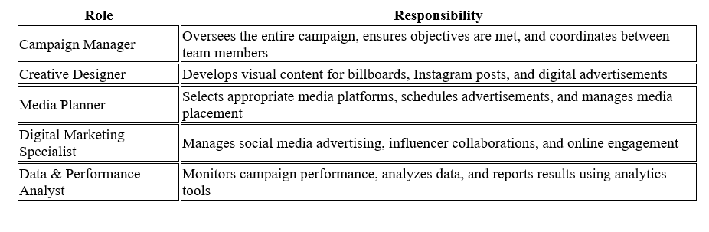

7.2 Campaign Timeline
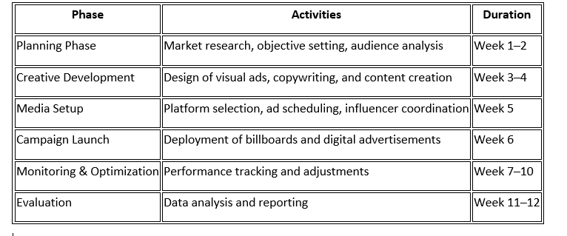
Budgeting Method and Allocation
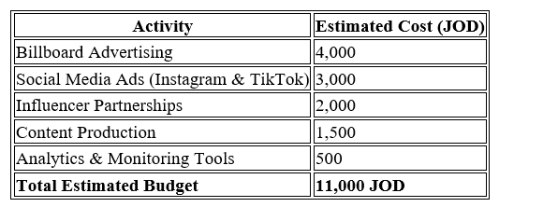

Performance Metrics & Impact Analysis
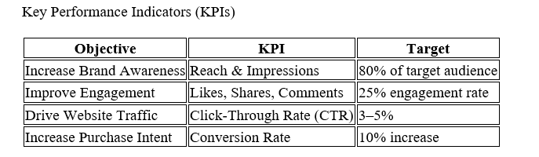

8.2 Measurement Tools and Analytics

The performance for each campaign will be measured utilizing recognized tools for analytics. Data on interactions and reach on Instagram and TikTok will come from Insights, while data on website interactions will be obtained from Google Analytics. Billboard success will be measured through location estimates and post-campaign surveys.

8.3 campaign evaluation

The data gathered after completing the marketing campaign will then be analyzed in order to determine if there was a fulfillment of objectives. The performance results are then contrasted against the earlier set goals in order to determine strengths and weaknesses for improvements in future marketing.

Recommendations & Future Improvements
Campaign Strengths and Weakness

A strength within the campaign can be identified within its visual identity and use of digital platforms, which target the viewing habits of the Jordanian consumer. A weakness is also identified within the use of social algorithms, which could impact audience reach unpredictably.

Future Advertising Strategies

Future campaigns should incorporate more of the localized content developed for the specific cities within Jordan. Greater efforts should be made to partner with locals in order to further increase authenticity. Also, incorporating campaigns about seasonally available promotions could increase the level of future engagement.

Technological and Artificial Intelligence Innovations

New advertising tools like AI-powered audience targeting, automated ad optimization, and predictive analytics can enhance efficiencies. Predictive analytics can become Innovative advertising instruments such as AI-driven audience targeting, automated ad optimization, and predictive analytics can improve efficiency Predictive analytics can become.

Commercials

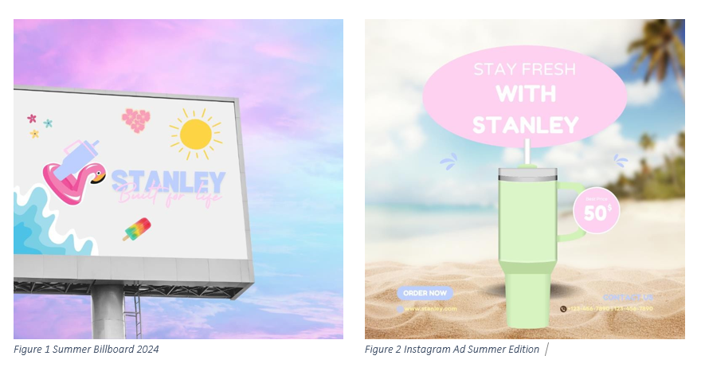

References
Augustin, T. (n.d.). These 9 Stanley Cup Alternatives Could Be the Next It-Girl Tumbler. Retrieved from birdie: htps://www.byrdie.com/stanley-cup-alternatives-8426460
Brand Focus: Are you a Stanley stan? (n.d.). Retrieved from campaign: htps://campaignme.com/brand-focus-are-you-a-stanley- stan/
BRAND IN FOCUS: Stanley is putting competitors on ice. (n.d.). Retrieved from slackline: htps://www.stackline.com/news/brand- in-focus-Stanley
EP74 | The problem with online communication - with Davina Stanley. (n.d.). Retrieved from htps://www.merilyn.com/blog/74 How Stanley, the Thermos for Tough Guys, Became the TikTok Obsession of Millennial Women. (n.d.). Retrieved 6 3, 2024, from
Bon Appetite: htps://www.bonappetit.com/story/stanley-black-friday
Teresia, E. (n.d.). The Stanley Cup Craze — a Social Listening Analysis. Retrieved from meltwater: htps://www.meltwater.com/en/blog/stanley-cup-marketing-case-study
Unraveling the Stanley Cup craze’s consumer marketing strategies. (n.d.). Retrieved from national: htps://www.national.ca/en/perspectives/detail/stanley-cup-consumer-marketing-strategies/
Abad-Santos, A. (2024, January 9). The Stanley water bottle craze, explained. Vox. htps://www.vox.com/culture/24031385/stanley-craze-tumbler-best-water-botle
Chayka, K. (2024, January 30). How the Stanley Cup Went Viral. The New Yorker. htps://www.newyorker.com/culture/infinite- scroll/how-the-Stanley-cup-went-viral
Market Positioning and the Context Filter: Stanley vs. Kodak. (n.d.). Innis Maggiore. htps://innismaggiore.com/news/blog/market-positioning-and-the-context-filter-stanley-vs-kodak/
Porter, B. (2024, January 9). 4 lessons the Stanley Cup craze is teaching us about maintaining originality. Forbes. htps://www.forbes.com/sites/britneyporter/2024/01/07/4-lessons-the-stanley-cup-craze-is-teaching-us-about-
maintaining-originality/?
Smith, S. (2024, January 11). Stanley cups: the psychology behind the internet’s latest obsession. Dazed. htps://www.dazeddigital.com/life-culture/article/61710/1/the-psychology-behind-the-stanley-cup-craze-quencher- tumbler-titoki-trend
Stanley 1913. (n.d.). About Stanley| Since 1913 | Built for life. htps://www.stanley1913.com/pages/about-stanley
Stanley 1913: Brand Positioning Case Study. (n.d.). htps://empathymarketing.co/blog/stanley-1913-brand-positioning-case- study
Stanley Cup Marketing Strategy - Soar with us. (n.d.). htps://www.soarwithus.co/blog/stanley-cup-marketing-strategy
Strategic Management Department. (n.d.). Stanley Black & Decker, Inc. PESTEL Analysis & Environment Analysis. Fern Fort University. htp://fernfortuniversity.com/term-papers/pestel/nyse4/2477-stanley-black---decker--inc-.php
Tarasova, A. G. a. E. (2024, April 9). Stanley cup — a Meltwater Social Listening Analysis. Meltwater. htps://www.meltwater.com/en/blog/stanley-cup-marketing-case-study
https://www.theguardian.com/lifeandstyle/2024/jan/12/stanley-cups-tumblers-water-bottle-trend
https://www.soarwithus.co/blog/stanley-cup-marketing-strategy

